**TSRT9 Code Assembler – Instructions for Use**

1. 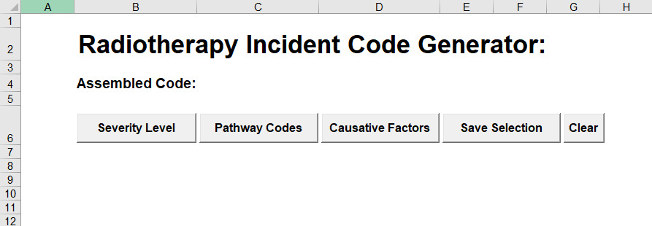The user would open up the spreadsheet from the QPulse URL on InPhase, as below
2. The user would press the “Severity Level” button to be greeted by the severity level form. Selection of a button will close the form and print the selected button to the main spreadsheet

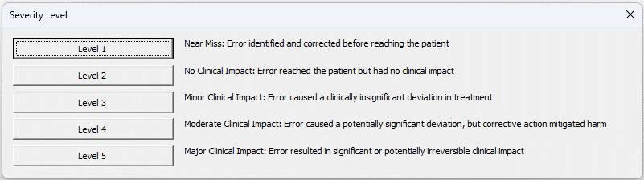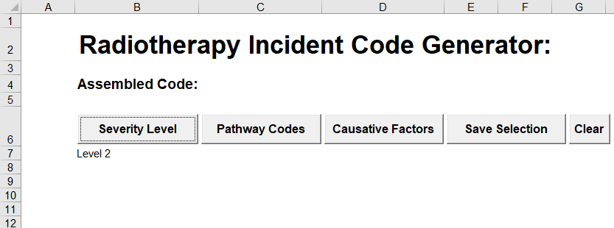

1. 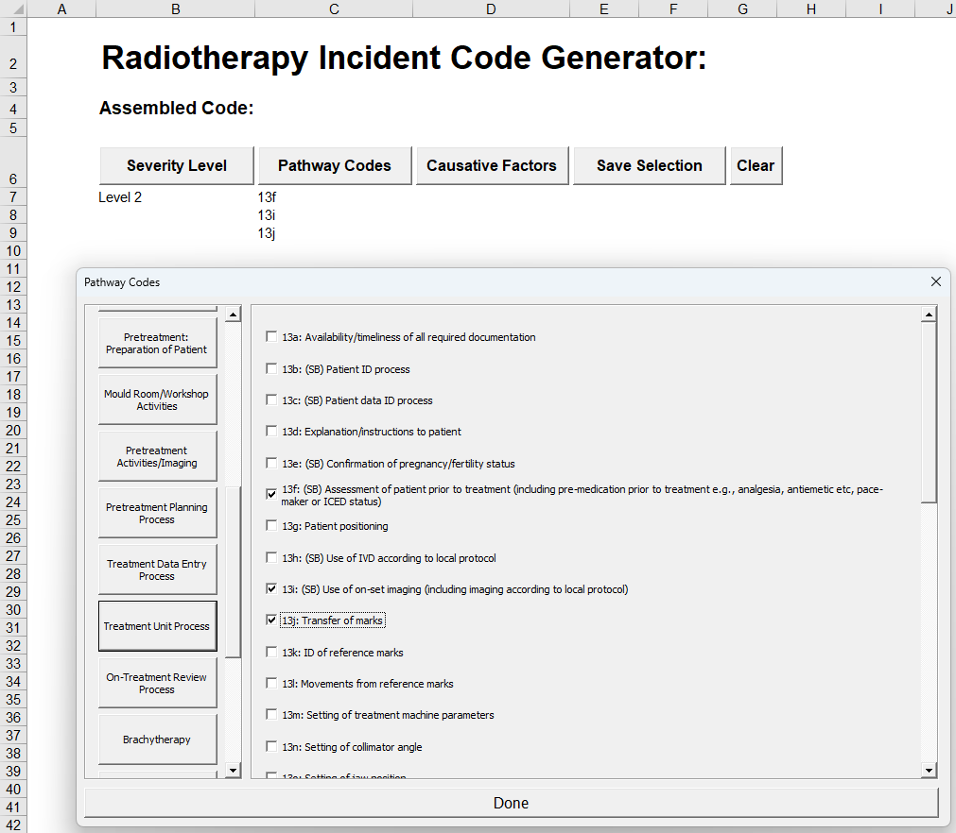The user would then select the “Pathway Codes” button to bring up the pathway codes form. Each of the different types of pathway codes can be accessed from the buttons on the left. The selections will appear in the spreadsheet as soon as the checkbox is selected and will automatically sort themselves.
2. 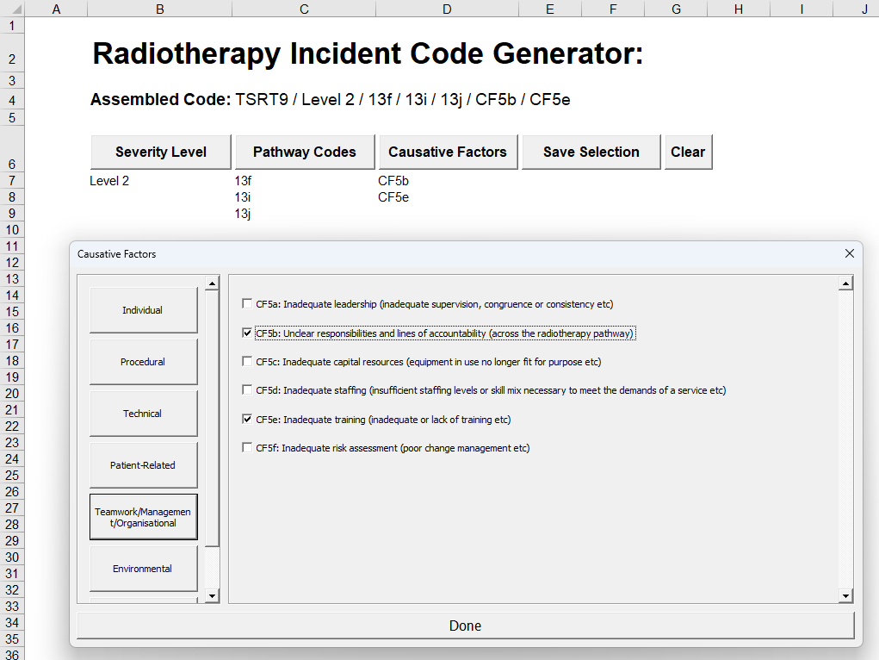The same can be repeated for the causative factors. The code can now be seen as there is now at least one entry for each of the options
3. At this point, if the code is selected (red box) then it will be exported to the users clipboard to paste into InPhase. A pop up messagebox will appear to inform the user this has occurred. There is a very strange bug with the function used to place this in the clipboard in that if a File Explorer window is open at all, the text will not be copied correctly

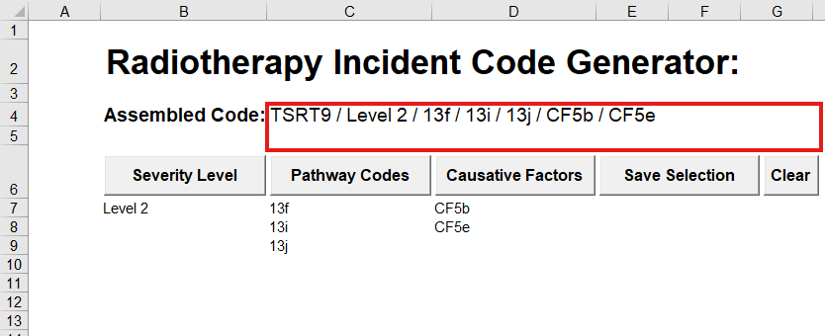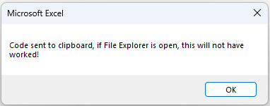

1. If at any point the user would like to save the current selection to return at a later point, the “Save Selection” can be pressed to save the current selection to their own files. The automatically generated filename for this contains the date for easy reference.
2. If at any point the user would like to restart, they can press the “Clear” button for all selections to be removed.